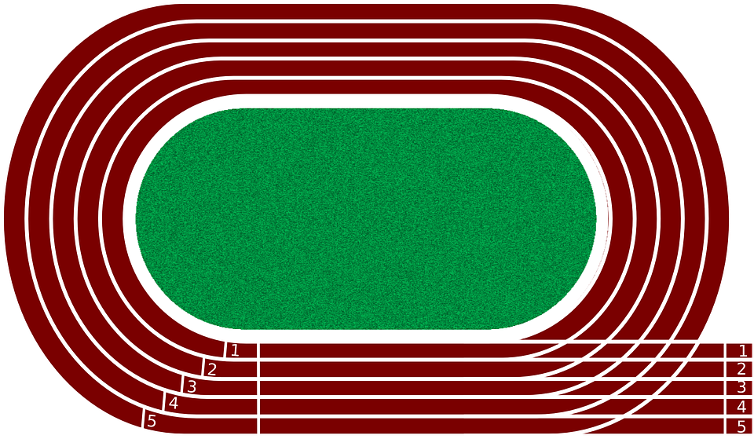

500, finish line after one full lap

From 300-meter finish line to 300 meter Starting line is for 100 meer sprints

250 Meters Finish

line

500, 300 & 250 Meters Starting line

300 Meters finish