2nd To None Track and Field Club
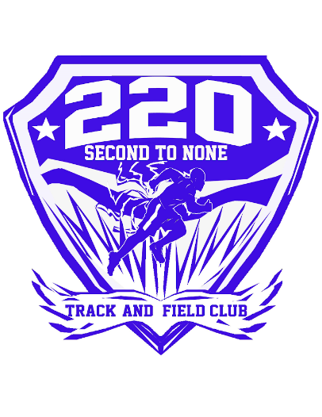
CAR WASH
SATURDAY, MAY 12
9:00 AM – 3:30 PM
Location: Burger King, RT 610
269 Garrisonville Rd, Stafford, VA 22554
THANK YOU FOR YOUR GENEROUS DONATION!!
Your support is appreciated as we prepare for a successful Track and Field Season!
Sponsored by 2nd To None Track and Field Club

