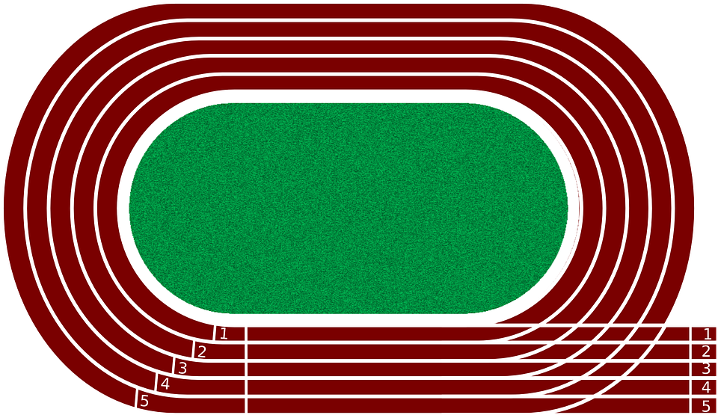

600 Meters Finish line after one lap

250 Meters Finish

line

800, 600 & 250 Meters Starting line

800 Meters Finish

line